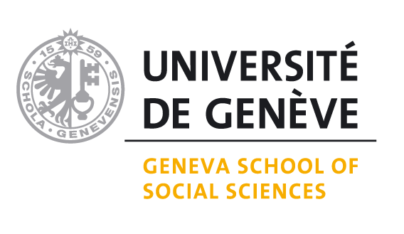

ARCHIVAL AUTHORIZATION FORM
Master’s thesis or Internship report
Note: for collective Master’s theses / Internship reports, each student has to complete this form

Student Nr. |  | Program: | MIHDS
Last name: |  | First name:
Department / Institute : | IGEDT | Grade obtained:
Thesis/Internship report title:
Has the self-analysis of the ethical dimensions been carried out? |  |  |  | YES

Student decision
I agree that my Master's thesis / Internship report is deposited in the UNIGE Open Archive for consultation:
YES |  | go to the next section to define the level of dissemination
NO |  | the Master’s thesis / Internship report will be deposited in the UNIGE Open Archive in non-distributed access (access is limited to the author(s) and the academic supervisor)

Student agreement
I confirm my agreement to deposit my/our Master's thesis/Internship report for consultation in the UNIGE Open Archive. I/we have ensured compliance with the rules of confidentiality as they were defined during the realization of the research. I/we have also obtained the copyrights for all figures, photos and graphics presented in my/our work and which were not produced by me/us or in an academic context.
Level of dissemination:
Access limited to UNIGE YES NO
Public access YES NO
Embargo period YES until ……………… NO
Date: Place: Signature:

Thesis/Internship report supervisor agreement
The above Master’s thesis/Internship report having obtained the minimum grade of 5, I/we confirm my/our agreement for depositing it in the UNIGE Open Archive for consultation with the access indicated above.

Academic supervisor
Last name: First name:
Date: Place: Signature:

Internship supervisor
Last name: First name:
Date: Place: Signature:

Please email the completed and signed form together with the final manuscript to your academic supervisor, with copy to Sandrine.Billeau@unige.ch

Please consult the relevant information on the G3S website : https://www.unige.ch/sciences-societe/faculte/organisation/commissions-de-la-faculte/commission-dethique/

