SOP for chloriding silver wires
Materials
- Ag wire
- Potassium chloride salt
- MiliQ water
- Cable
- Banana connection
- Soldering iron
- Pt electrode
- Autolab Potentiostat
Experimental Procedure
Cut the Ag wire in a desired length and connect it with a cable by using the soldering iron. At the end of the cable connect a banana connection. Before use check electrical connections with polymeter to see if the soldering between the wire and cable is successful.
Immerse both Ag and Pt wires into 3M KCl solution and connect the Ag wire with the anode and Pt wire with cathode in potentiostat instrunment. Practically Ag wire is connected with WE+S connection and Pt wire with CE+RE connection, respectively.
Run the following method by using NOVA software:
Electroplating a silver wire with chloride is achieved by making the wire positive(anode) with respect to the solution KCl (3M) and passing a current through the electrode at a rate of 1 mA/cm2 of surface area for 10-15 seconds. The color of a well plated wire should be purple-gray. Periodic reversal of the polarity while plating the electrode tends to yield a more stable electrode. When electroplating a previously plated wire, you may find that it does not plate evenly. Complete removal of the residual silver chloride is usually necessary to effect a uniform coat. Before making the wire positive to the chloriding solution, reverse the polarity for 5 to 10 seconds to remove any remaining chloride that might be left in pits on the wire. Then proceed as described above.
Note: Chlorided wire should be monitored over time for degradation during use. This will usually be apparent as either a change in color or an increased drift in the junction potential, or both. Degraded electrodes should be replated using the above described procedures.
From my experience Ag/AgCl electrodes should be replated every 2-3 weeks after a daily and long use.

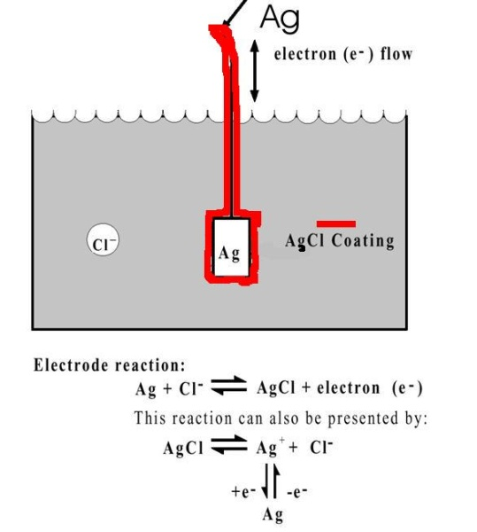

GOOD LUCK!!
Maria Tsemperouli
22/11/2016

