SEMINAIRE DU DEPARTEMENT DE MINERALOGIE

Mardi 18 mars à 17.15, salle 102

Prof. Thomas Nägler
Institut für Geologie, Universität Bern

Redox fingerprints of Earth evolution: Mo isotopes and the history of free oxygen


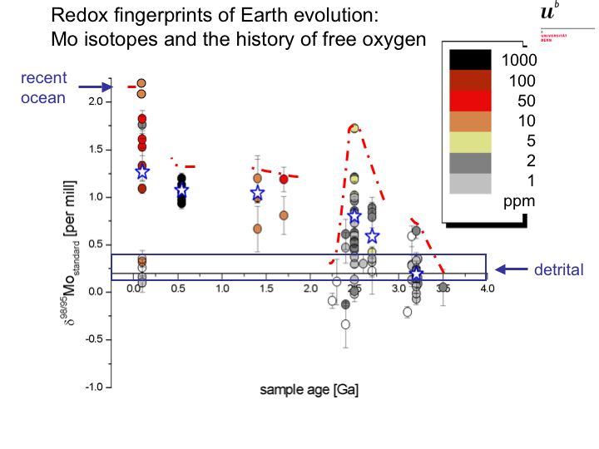
Knowing the extent of ocean anoxia is a basic problem in Earth Sciences. It starts with the very question of initial oxygen rise in early Earth atmosphere and continues with the association of widespread anoxia with the Cambrian explosion and Phanerozoic mass extinction events. Thus periods of oceanic oxygen deficiency were very important features of Earth history, in particular for the evolution of life. Yet the chemical records of those events are limited and often lack high temporal and spatial resolution. Mo isotopes provide a new independent tool for the evaluation of the extent of anoxic events and serve as fingerprints of the evolution of free oxygen.

